Accessible Earth observations are critical for sustainable and safe tourism in the Caribbean

Douglas Cripe, GEO Secretariat, and Hans-Peter Plag, Coastal Zone Community of Practice

The workshop on "Earth Observation Support for Sustainable Tourism in Small Island States," San Juan, Puerto Rico, March 9-11, 2011 was jointly organized by the GEO Secretariat and the Coastal Zone Community of Practice (CZCP) in partnership with the Caribbean Regional Association (CaRA) for the Caribbean Integrated Coastal Ocean Observing System (CarICOOS), the Global Ocean Observing System (GOOS), the Global Terrestrial Observing System (GTOS), the United Nation Educational, Scientific, and Cultural Organization (UNESCO), and the Intergovernmental Oceanographic Commission (IOC). This Third Regional Workshop of the CZCP workshop series focused on the specific needs, challenges and capabilities related to sustainable tourism in the small island states of the Caribbean. The workshop brought together more than 55 participants from most of the small Island States in the Caribbean and from the USA for a dialog between the stakeholders in island tourism and the service providers of Earth observation data and services, focussing on how Earth observation-based services could support decision making related to all facets of tourism and enable operational and planning practices for sustainable tourism.

During the first day, invited presentations reviewed decision issues and processes from the user perspective on the one hand, and the observation capabilities and services from providers on the other. The second day was devoted to breakout sessions identifying those decision processes that could benefit from improved Earth observation-based support. The importance of easily accessible information derived from Earth observations as well as the need of end-users to have access to expertise were emphasized. Perception of safety and risk determines to a large extent the attractiveness of destinations for tourism, and hazards and disasters can rapidly change this perception. Hazard and risk mapping as well as early warning were recognized as areas where Earth observations are critical for sustainable tourism.

Based on the outcome of these breakout sessions, during the third day recommendations were drafted with the goal to facilitate a post-workshop linkage between providers and end users. Recognizing that regional tourism organizations adhere to the United Nations World Tourism Organization (UNWTO), the recommendations urge GEO to invite UNWTO to consider becoming a Participating Organization. Acknowledging the importance of the regional intergovernmental organizations, the GEO Secretariat is asked to take steps towards a dialog with these organizations. The CZCP is asked to develop a web-based information tool for the exchange of information relevant for the coastal zone, and it is recommended that stakeholders in the region be familiarized with GEO facilities (GEO Portal, GCI, User Requirement Registry, etc.) in the frame of a pilot project. The representatives of regional tourist organizations (Caribbean Tourist Organization, CTO, and the Caribbean Hotel and Tourism Organization) expressed strong interest in a continued dialog with GEO and it was recommended that a GEO Secretariat expert give presentations to the relevant organizations of the region.

During the workshop, close links were established between representatives of regional organizations such as IOCARIBE, CDEMA, and the CZCP and GEO Secretariat. It is expected that these new links will rapidly lead to pilot projects which, on the one side will make available GEOSS facilities to the end users in the region and, on the other side, provide user feedback to GEO from end user groups not yet sufficiently linked to GEOSS.

The workshop presentations and other workshop documentation are available on the workshop web page at http://www.czcp.org/workshops/Puerto_Rico.
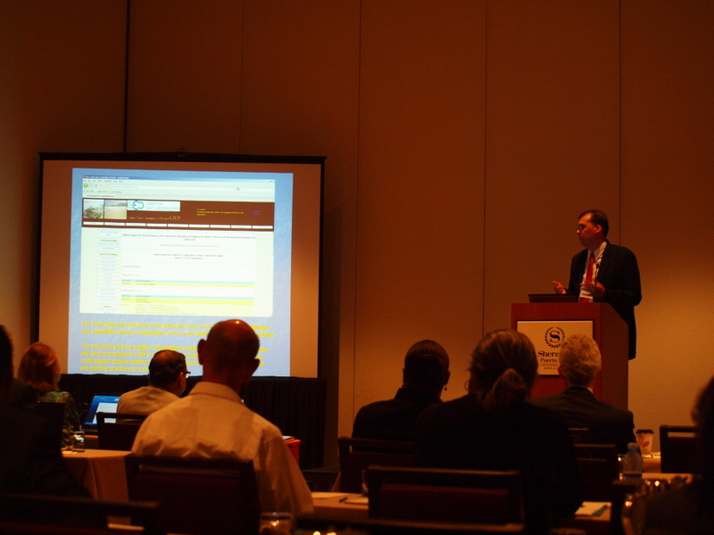
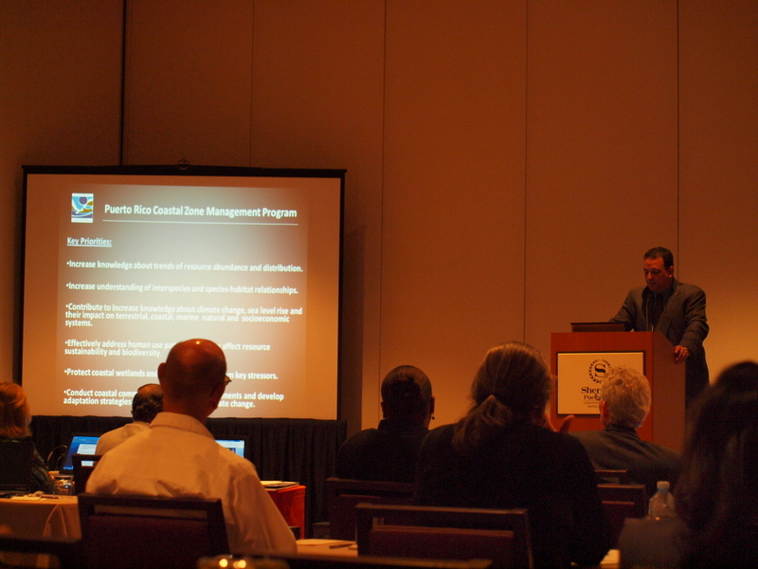
A1: Figure 1: Paul DiGiacomo, Co-Chair CZCP, welcomed the participants on behalf of the CZCP and gave an overview of the work of this GEO CoP.

A2: Figure 1: During his keynote in the Opening Session, Ernesto Diaz, used the example of Puerto Rico to illustrated the complexity of coastal zone management.

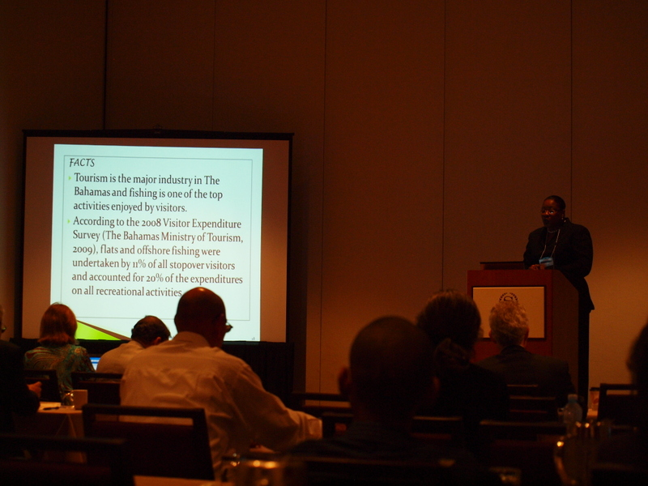
A3: Figure 1: Sophia Rolle, The Bahamas, addresses the conflicts between tourism and ecosystems and underlined the importance of Tourism for the region.

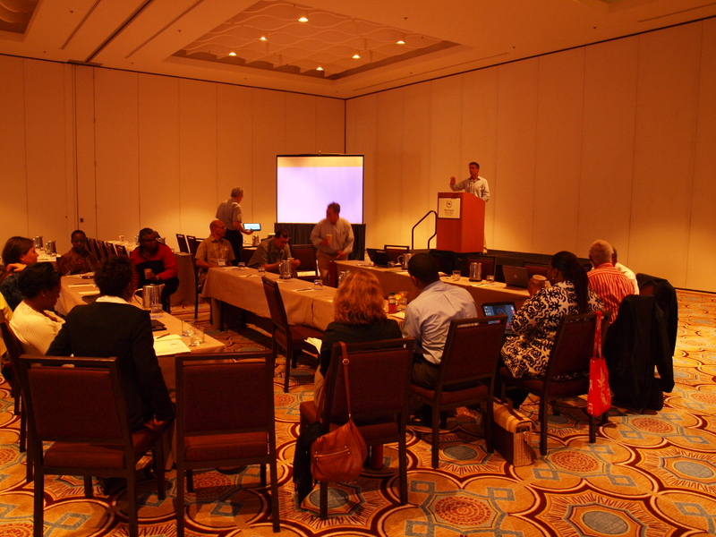

Figure 2: Breakout session during Day 2 provide ample time to discuss ways toward improved decision support through earth observations and better linkage between the stakeholder of tourism in the region and the GEO community.
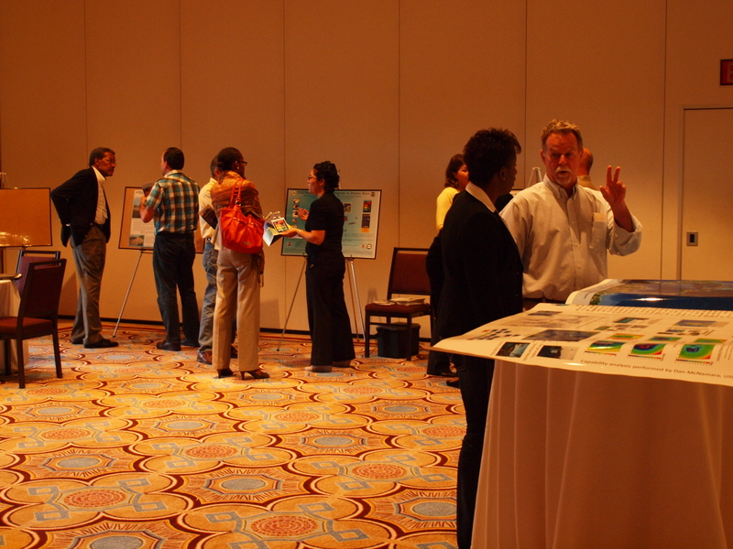
Figure 3: A poster session allowed for more discussions and the development of ideas for pilot projects bring together providers of the GEO community and end users in the region.

